Mid-Term Exam

**Question 1**

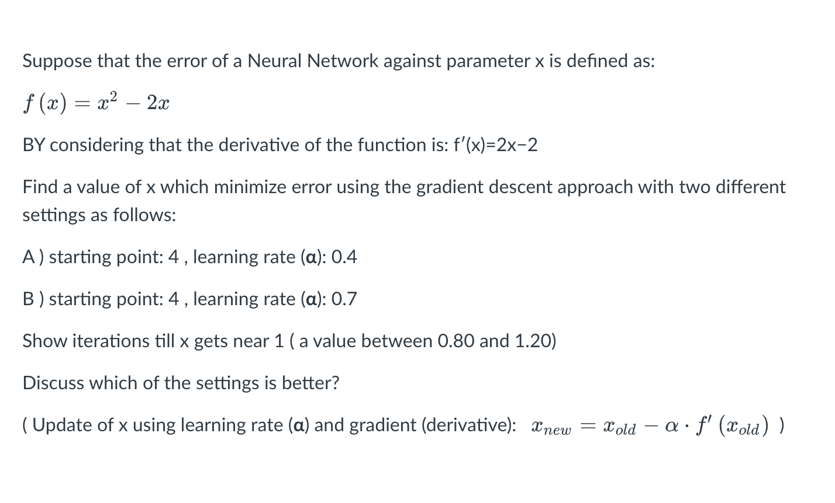

|  |  |  |  |  |  |  |  |  |  |
| --- | --- | --- | --- | --- | --- | --- | --- | --- | --- |
|  | 1 | 2 | 3 | 4 | 5 | 6 | 7 | 8 | 9 |
| 0.4 | 1.6 | 1.12 |  |  |  |  |  |  |  |
| 0.7 | -0.2 | 1.48 | 0.808 |  |  |  |  |  |  |

So, ‘A ) starting point: 4 , learning rate (**α**): 0.4’ is better, use less iterations.

**Question 2**

ReLU(H11) = Max(10*(-0.4) + 20*0.1, 0) = Max(-2, 0) = 0

ReLU (H12) = Max(10*0.2 + 20*0.1, 0) = Max(4, 0) = 4

ReLU (H21) = Max(0*0.7 + 4*0.1, 0) = Max(0.4, 0) = 0.4

ReLU (X22) = Max(0*0.8 + 4*0.2, 0) = Max(0.8, 0) = 0.8

Sig (O1) = Sig(0.4*(-0.5) + 0.8*0.5) = Sig(0.2) = 0.54

Since 0.54 > Threshold 0.5, so we predict Heart_Attack(1)

**Question 3**

Iteration 1: Count Pairs

Counting pairs of adjacent symbols in the dataset:

- `("l", "o")`: 2

- `("o", "w")`: 2

- `("w", "e")`: 1

- `("e", "r")`: 2

- `("h", "i")`: 2

- `("i", "g")`: 2

- `("g", "h")`: 2

- `("h", "e")`: 2

Most frequent pairs with `frequency >= 2`:

- `("l", "o")`, `("o", "w")`, `("e", "r")`, `("h", "i")`, `("i", "g")`, `("g", "h")`, `("h", "e")`

Choose `("l", "o")` to merge (order is not important).

Iteration 1: Merge `("l", "o")`

After merging `("l", "o")` to form `lo`:

1. `"lo w"`

2. `"lo w e r"`

3. `"h i g h"`

4. `"h i g h e r"`

Iteration 2: Count Pairs

- `("lo", "w")`: 2

- `("w", "e")`: 1

- `("e", "r")`: 2

- `("h", "i")`: 2

- `("i", "g")`: 2

- `("g", "h")`: 2

- `("h", "e")`: 2

Merge `("lo", "w")`.

Iteration 2: Merge `("lo", "w")`

After merging `("lo", "w")` to form `low`:

1. `"low"`

2. `"low e r"`

3. `"h i g h"`

4. `"h i g h e r"`

Iteration 3: Count Pairs

- `("e", "r")`: 2

- `("h", "i")`: 2

- `("i", "g")`: 2

- `("g", "h")`: 2

- `("h", "e")`: 2

Merge `("e", "r")`.

Iteration 3: Merge `("e", "r")`

After merging `("e", "r")` to form `er`:

1. `"low"`

2. `"low er"`

3. `"h i g h"`

4. `"h i g h er"`

Iteration 4: Count Pairs

- `("h", "i")`: 2

- `("i", "g")`: 2

- `("g", "h")`: 2

- `("h", "e")`: 2

Merge `("h", "i")`.

Iteration 4: Merge `("h", "i")`

After merging `("h", "i")` to form `hi`:

1. `"low"`

2. `"low er"`

3. `"hi g h"`

4. `"hi g h er"`

Iteration 5: Count Pairs

- `("i", "g")`: 2

- `("g", "h")`: 2

- `("h", "e")`: 2

Merge `("i", "g")`.

Iteration 5: Merge `("i", "g")`

After merging `("i", "g")` to form `ig`:

1. `"low"`

2. `"low er"`

3. `"hi gh"`

4. `"hi gh er"`

Iteration 6: Count Pairs

- `("g", "h")`: 2

- `("h", "e")`: 2

Merge `("g", "h")`.

Iteration 6: Merge `("g", "h")`

After merging `("g", "h")` to form `gh`:

1. `"low"`

2. `"low er"`

3. `"high"`

4. `"high er"`

Iteration 7: Count Pairs

- `("h", "e")`: 2

Merge `("h", "e")`.

Iteration 7: Merge `("h", "e")`

After merging `("h", "e")` to form `he`:

1. `"low"`

2. `"lower"`

3. `"high"`

4. `"higher"`

Final Result

The final subword vocabulary is:

`"low"`, `"lower"`, `"high"`, `"higher"`

**Question 4**

Suppose that word embeddings (with the same dimensions) were created using an approach which preserves relationships between embeddings precisely.

A) If the following equations are correct calculate the embedding of “brothers”:

E(students) - E(student) = [0,0,2]

E(father) - E(mother) = [0,1,0]

E(sister)=[-2,1,0]

E(brothers)= ?

B) Suppose that the following sentence is processed using self-attention mechanism and the context is already added to embeddings of words. What is the embedding of “sibling” after adding the context by the self-attention?

Sentence: “I have one male sibling”

E(sibling)= ?

A)

Since E(sister) = [-2,1,0] and E(father) - E(mother) = [0,1,0],

So E(brother) = E(sister) + [0,1,0] = [-2,2,0]

Since E(students) - E(student) = [0,0,2],

So E(brothers) = E(brother) + [0,0,2] = [-2,2,2]

B)

E(sibling) = [E(brother) + E(sister)] / 2 = [−2,1.5,0]

Given the presence of "male" in the sentence, the self-attention mechanism will adjust E(sibling) toward E(brother).

Adding the gender shift vector [0,1,0] for male context:

E(sibling) with context = [−2,1.5,0]+[0,0.5,0]=[−2,2,0]

**Question 5**

Greedy:

I + buy (0.25) + it(0.10)

Beam Search (beam width=3):

|  |  |  |  |
| --- | --- | --- | --- |
| First word | Probabilities - Step1 | Probabilities - Step2 |  |
| I | have (0.20) | this(0.10) | 0.02 |
| that(0.15) | 0.03 |
| it(0.20) | 0.04 |
| not(0.05) | 0.01 |
| buy (0.25) | it(0.10) | 0.025 |
| nothing(0.05) | 0.0125 |
| anything(0.01) | 0.0025 |
| something(0.05) | 0.0125 |
| had(0.15) | this(0.10) | 0.015 |
| that(0.10) | 0.015 |
| it(0.20) | 0.03 |
| not(0.02) | 0.003 |
| got (0.10) | nothing(0.05) | 0.005 |
| it(0.20) | 0.02 |
| something(0.10) | 0.01 |
| this(0.10) | 0.01 |

So Beam Search Result is "I have it" with the highest cumulative probability 0.04.